Pentecost Candle

Create or draw a Pentecost Candle using Option 1 or 2

Option 1 - Celebrating with different languages
Create or draw a Pentecost Candle & learn to say 'Hello' in twenty-one other languages.
Pentecost falls 50 days after Easter Day. Traditionally the Paschal Candle which is lit on Easter Day is extinguished at Pentecost & congregations are invited to take the light (the Good News of Jesus) out into their communities & share it with those they meet, just as the disciples did on that first Pentecost.
This Pentecost Candle not only reminds us of that light but also the Holy Spirit which brought tongues of fire enabling the disciples to speak in many languages so they were able to share the good news with everyone around them.
On your candle, write or type 'Hello' translated into 21 different languages, all of which can be colored in if you wish. Alongside each translation, please provide the name of the country where the greeting is from.
This is such a neat way for kids to explore & learn simple greetings from around the world, as well as reminding them that their church family stretches way beyond their own country, & that they are part of a worldwide church family united in celebrating Pentecost.

Option 2 - Celebrating with Symbols
Create or draw a Pentecost Candle & learn what the different symbols of the Church mean.
The candle represents Christ being the light of the world, and is the first light that enters the dark church on Easter Vigil. The candle is lit from the blessed Easter fire. A new Paschal Candle is used by each church each year, helping the parish enter into the Easter Mystery each new year.
On your candle, start the year and then research and discuss some symbols you may be able to draw and color. Next to each Symbol, write what the symbols represents.
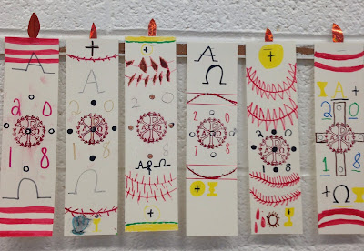
Such as: lamb, chalice, host, grapes, wheat, water, flames, cross, dove, etc.
For older students: The Chi Rho symbol, the first two letters of Christ in Greek OR The Alpha & Omega, the first and last letters of the Greek alphabet, symbolizing that Christ is the beginning and the end.

Use your imagination and take this project as far and unique as you like, these are just examples.
When your child is done, please take a photo of the project and send it to me, Lori.s@JP2Parish.org OR drop it off at the Church and we would love to put it on display!

