Saint John Paul II Parish & St. Mary’s of the Lake Parish

2024 First Reconciliation
Artists Wanted

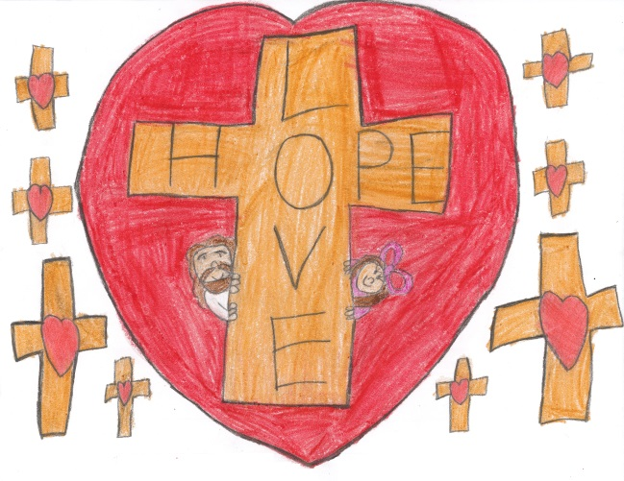
We need artwork for the programs for the First Reconciliation Ceremony. Any student making their First Reconciliation is eligible to submit original artwork to be used anywhere in the program or signage around the Church.

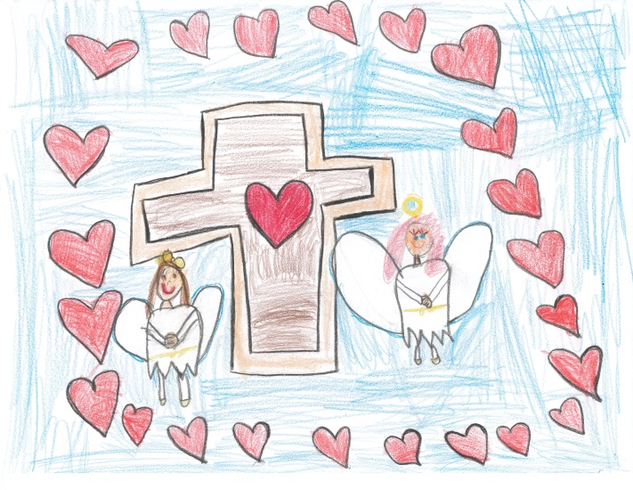
Our request is that the artwork is completed by the child only (No help, Mom & Dad!), the child must be part of this year’s 2024 First Reconciliation class (no siblings) and it must be of the Reconciliation/Religious theme (Cross, Rosary, Lamb, Etc.).

This is NOT a requirement. Please ONLY submit one drawing, coloring or painting (can be in color or black & white). We may not be able to use all entries, but we will try!

We need all artwork by February 25th, 2023 (or submitted to their teacher any time before that date). Artwork can also be emailed to Lori.S@JP2 Parish.org in high resolution. Please label all entries with first and last name on the back!

Have fun!

