Saint John Paul II Parish
2023 First Reconciliation
Artists Wanted

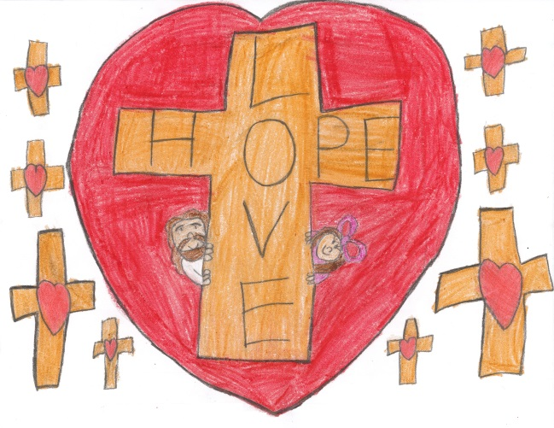
We need artwork for the programs for the First Reconciliation Ceremony on Monday, March 20, 2023. Any student making their First Reconciliation is eligible to submit original artwork to be used anywhere in the program or signage around the Church.

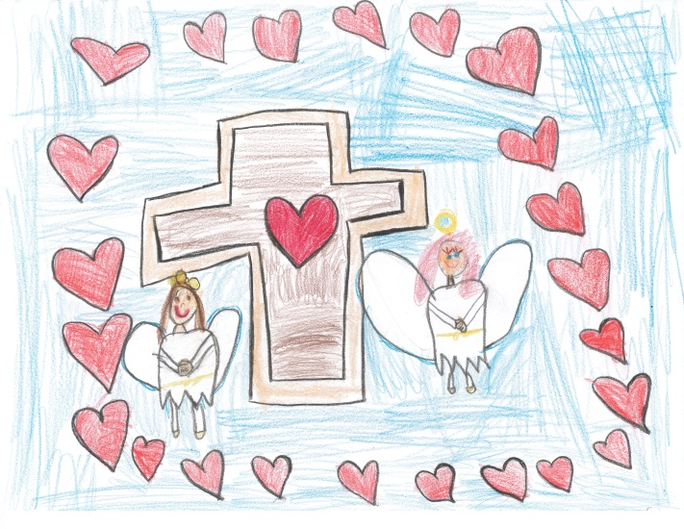
Our request is that the artwork is completed by the child only (No help, Mom & Dad!), the child must be part of this year’s 2023 First Reconciliation class (no siblings) and it must be of the Reconciliation/Religious theme (Cross, Rosary, Lamb, Etc.).

This is NOT a requirement. Students may submit more than one drawing or painting (can be in color or black & white). We may not be able to use all entries, but all entries will be considered and greatly appreciated.

We need all artwork by March 5, 2023 (or submitted to their teacher any time before that date). Please label all entries with first and last name on the back!

Have fun!

