Important Things to Know to Receive Reconciliation

Understanding What Is a Sin

The word “sin” comes from a Latin word which means “to miss the mark”. If our goal is to get to heaven, then our sins keep us from “hitting the mark”, or the ideal order established by God.

When we sin, we knowingly:
- CHOOSE to do what is wrong OR
- FAIL TO DO what is right

Sin is making a choice to do something wrong. Sin always hurts both the person who sins and the community because the person is not loving and caring for everyone as God wants.

There are 2 kinds of sin: venial sin and mortal sin.
  - A venial sin is a lesser sin. It is when a person is not being as good a friend to God and to people as God wants.
  - A mortal sin is a serious sin. The person completely breaks off his or her friendship with God.

Sin hurts the sinner and the community. It puts distance between the individual and God, and between the individual and the community. It violates the ideal relationship between the individual and God, and diverts us from the ideal order in the community.

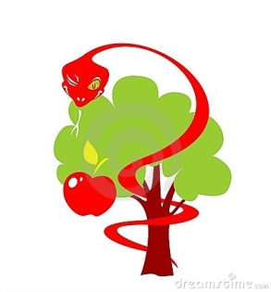
Conditions Necessary for Sin

- The individual has an awareness of general standards of right and wrong.
- The person knows that an act is wrong.
- The person chooses to participate in the wrong action anyway.
- The person fails to do a good/right thing when the opportunity.

Showing a Desire to Receive Reconciliation
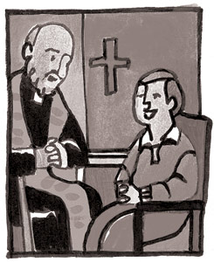
- The individual recognizes that he/she has done something wrong,
or didn’t do the right thing when he/she had the chance
- The individual feels sorrow for anything they have done
- The individual wants to show that he/she is sorry
- The individual has the desire be a better person and grow as part
of the Catholic Family
- The individual wants God’s help to be more like Jesus

A Sin or an Accident?

As concrete thinkers, young children can understand actions as right and wrong, but sometimes youngsters have difficulties understanding motives. This can lead to some confusion over exactly what is a sin and what isn’t. For example, children who forget to do something they were asked to do may think they have disobeyed. In order to form their consciences appropriately, it is important that children understand the difference between a sin and an accident, or mistake. Parents can help make this distinction clear by posing hypothetical situations and asking the children to tell if what is described would be a sin or an accident.

Better still, they can point out examples in their own family lives, such as when something is accidently dropped and broken, or when a child intentionally disobeys. To help make this distinction clear, be sure not to get overly upset or punitive at rule infractions at home that are truly accidental, but also point out that feeling sorry about a wrong choice we have made does not make that choice an accident. The real question is, “Did we do it on purpose?”

Why Confess My Sins to a Priest?

Sin injures our relationship with God AND with his Body, the Church. Sinning breaks our unity with God and one another. Therefore, we need to be reconciled (to restore our relationship) with the Church as well as God.

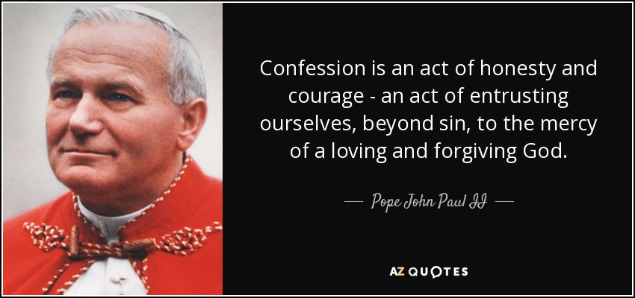
In the Sacrament of Reconciliation, the priest represents Christ, but also Christ’s Body, the Church. The sacrament of Reconciliation is how we restore communion between ourselves, God, and the Church – not God alone.

According to the Catechism of the Catholic Church (CCC, 1441-1442) only God can forgive sins. But we must remember that Christ also allowed for this power to be mediated through his Apostles. On the night of his resurrection, he told them, “Whose sins you forgive are forgiven, and whose sins you retain are retained.” Thus, the successors of the Apostles, our priests and bishops are now entrusted with the ministry of reconciliation (CCC, 1461).

The priest himself is not actually forgiving sins; he prays the prayer of absolution that expresses God’s forgiveness: “Through the ministry of the Church may God give you pardon and peace, and I absolve you from your sins in the name of the Father, and the Son, and of the Holy Spirit.”

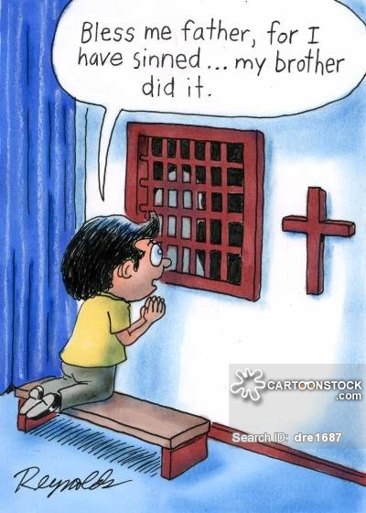
Confessing our sins out loud to a priest helps us to “own our sins” and to “take responsibility for them, and thereby open again to God and to the communion of the Church in order to make a new future possible.” (CCC, 1455).

The Seal of the Confessional

A priest can’t make use of the knowledge of any sin he has gained in sacramental confession (even in the case of murder).

This is known as the “sacramental seal”, because “what the penitent has made known to a priest remains ‘sealed’ by the sacrament’’ (CCC, 1467). A priest who breaks the seal would be excommunicated from the Church, and only the Pope could restore him to his role as priest.

