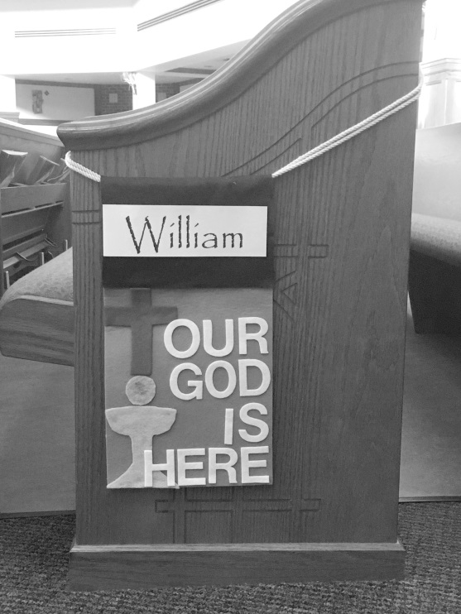
FIRST EUCHARIST
FAMILY BANNER PROJECT

Banner dimensions
Your finished banner must be
no longer than 9” x 17”.
Photo to the left is the placement on the pew in the
Church; this is why the size of your
banner is important.

Suggested Banner Materials
Background Fabric, such as felt, burlap, cotton, muslin, or linen; decorative accents made from the same materials, stitched or glued to the background. Fabric paints, silk flowers, stalks of wheat, rosary beads, pictures, etc. may be used. However, be considerate of the weight these items add to the banner!!! Excessive weight will prevent your banner from hanging evenly or dropping off during mass
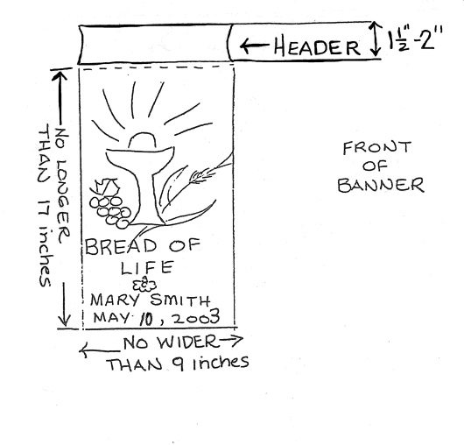
Instructions:
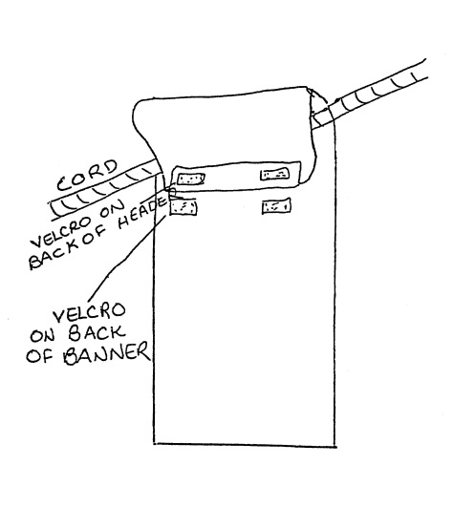
- Each banner must have “header”; Velcro strips should be attached to the back of the header, with corresponding Velcro strips on the back of the banner. The header will be folded over the cord loop and secured by the Velcro. (see diagrams)
- The child’s name and date of the First Communion should be included in the banner design. The design should be of a religious theme only.
- Banners should be brought to the Faith Formation Office no later than April 30th.
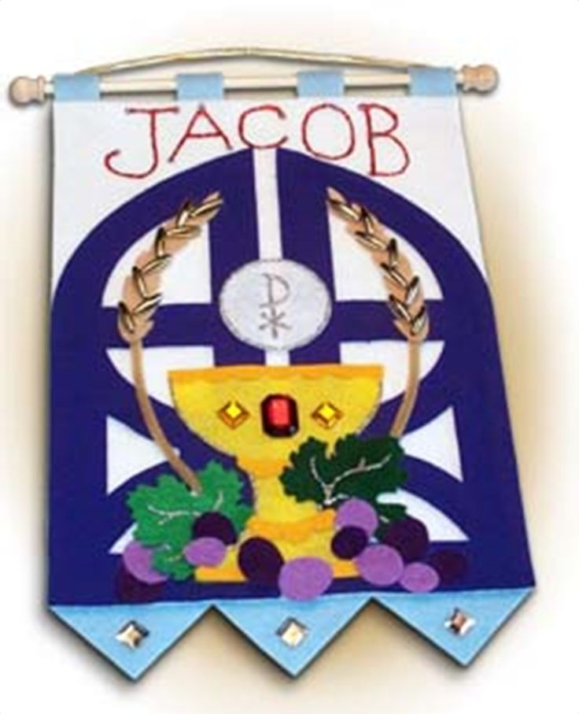
- They may be removed and taken home with you after your First Communion Mass.

You can find banner making kits at Amazon, Party City, AC Moore, Joann’s, Michaels, etc. or be adventurous and make your own.

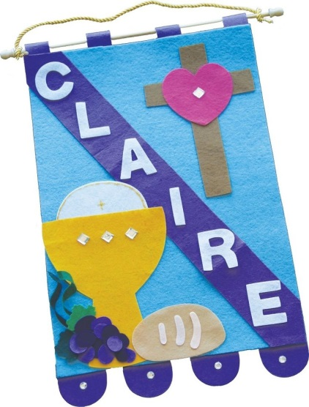
Symbols of Communion, Church, etc.
Grapes Cross Chi Rho
Wheat Sun Church
Chalice Dove Olive Branch
Bread Heart
Host Praying Hands

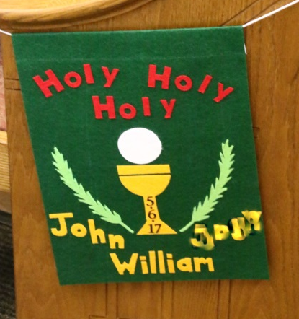
Communion Phrases
Jesus, Bread of Life Body of Christ
You Are Near Come To My Heart
Jesus, Thank You We Come to Your Table
One Bread, One Body

