Examination of Conscience

(Especially for 2nd and 3rd graders)

Let us think about God:
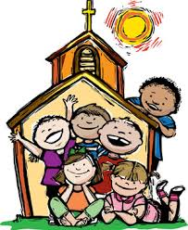

Have I said my prayers and gone to church on Sunday?
Do I speak Gods name in a respectful way?
Do I participate in Mass by listening, saying the
responses, and acting with reverence?
Do I praise and thank God for all the gifts I have been
given in life?
Do I ask God for help in all that I do?

Let us think about ourselves:

Do I respect my body and do things that show I care for it?
Do I eat properly, go to bed on time, and stay away from unnecessary risks?
Do I speak kindly to all I meet?
Am I lazy and unwilling to try to do my part?

Let us think about others:

Do I lie to others?
Do I lie about others?
Do I fight with others?
Do I call others names?
Do I take things that belong to
others?
Do I try to make others unhappy
when I do not get my way?
Do I do what my parents and
teachers ask?
Do I try to see how much I can get
away with by cheating lying or stealing?

Examination of Conscience (for adults)
- How long has it been since my last confession?
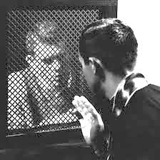
- Did I conceal any sin?
- Did I do my penance?
- Have I neglected my home or family duties, work or school?
- Have I been lazy, neglectful, or willfully distracted at prayer
or Holy Mass?
- Have I used God’s name irreverently, or taken false or
unnecessary oaths?
- Have I missed Holy Mass on Sundays or Holy Days through my own fault?
- Have I done unnecessary work on Sunday?
- Have I disobeyed, or been disrespectful to my superiors (parents, teachers, employer)?
- Have I been unjust or unkind to those under my authority?
- Have I quarreled with or purposely hurt anyone?
- Have I been cruel (physically or mentally) to anyone?
- Have I had an abortion or assisted someone else to have one?
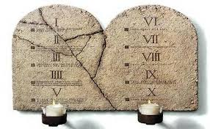
- Have I cause or led anyone else to commit sin?
- Have I offended against purity in thought, word or deed?
- Have I stolen or destroyed another’s property?
- Have I accepted stolen goods?
- Have I paid my just debts?
- Have I scandalized or been a bad example to my family or others?
- Have I lied, repeated gossip, or hurt another’s character?
- Have I been sinfully proud, greedy, angry, envious, jealous, or intemperate in eating or drinking?
- Have I used illegal drugs or abused controlled substances?
- Have I observed the Church’s laws or fasting and abstinence?
- Have I failed to support the Church?
- Have I received Communion during Eastertime?
- Have I sinned against the duties of married life?
- Have I failed to show the love, respect, and good example due my spouse?
- Have I neglected my duties to my children concerning their religious instruction, education, or cultivation of good habits?

Act of Contrition
My God,
I am sorry for my sins with all my heart.
In choosing to do wrong
and failing to do good,
I have sinned against you
whom I should love above all things.
I firmly intend, with your help,
to do penance,
to sin no more,
and to avoid whatever leads me to sin.
Our Savior Jesus Christ
suffered and died for us.
In His name, my God, have mercy.
Amen.

The Hail Mary
Hail Mary, full of grace,
the Lord is with thee;
blessed art thou among women,
and blessed is the fruit
of thy womb, Jesus.
Holy Mary, Mother of God,
pray for us sinners now
and at the hour of our death.
Amen.

The Apostle's Creed
I believe in God, the Father almighty,
creator of heaven and earth.
I believe in Jesus Christ, his only Son, our Lord.
He was conceived by the power of the Holy Spirit
and born of the Virgin Mary.
He suffered under Pontius Pilate, was crucified,
died, and was buried.
He descended to the dead.
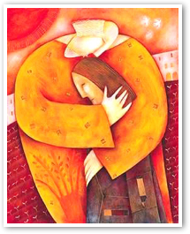
On the third day he rose again.
He ascended into heaven,
and is seated at the right hand of the Father.
He will come again to judge the living and the dead.
I believe in the Holy Spirit, the holy Catholic Church,
the communion of saints, the forgiveness of sins,
the resurrection of the body, and the life everlasting.
Amen.

The Lord's Prayer
Our Father, who art in heaven,
hallowed be thy name,
Thy kingdom come,
Thy will be done, on earth as it is in heaven.
Give us this day our daily bread,
and forgive us our trespasses as we forgive those
who trespass against us,
and lead us not into temptation,
but deliver us from evil.
Amen.

Glory Be
Glory be to the Father and to the Son
and to the Holy Spirit, as it was in the beginning,
is now and ever shall be, world without end.
Amen.

