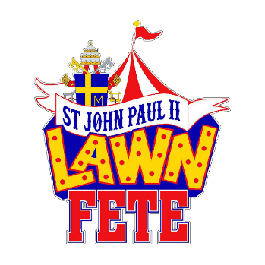
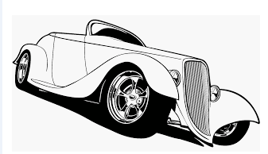
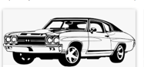
St John Paul II 2nd Annual Car Show
Rain or Shine & Fun
Friday Night July 15th from 5 - 8 pm
Gates Open @ 4:30 pm, Judging starts @ 7 pm, Awards @ 8:30 pm
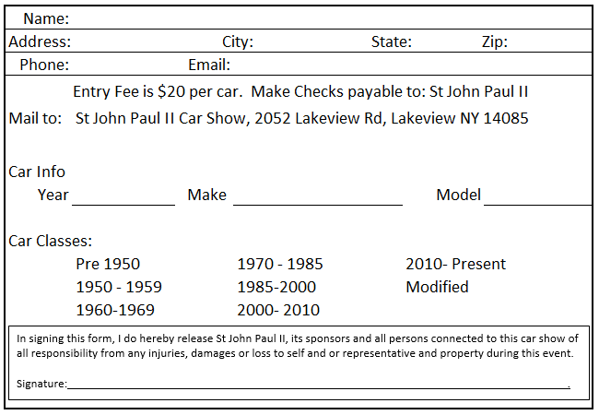
St John Paul II Car Show, 2052 Lakeview Rd, Lake View NY 14085
Music by
Heard of Buffalo
7 pm to 11 pm
Questions, please call John Berkhoudt @ 716-598-5960
Music, Food & Family Fun
Basket Raffles & Grand Raffle

