Church Tour Items

Check off each item as you locate it.

- Holy water font (Take holy water and bless yourself as you enter & exit the church)
- Baptismal font
- Altar (Bow when crossing in front of the altar)
- Pews (Genuflect when entering & leaving the pew)
- Candles
- Paschal (or Easter) candle
- Lectern
- Cross or Crucifix
- Stained glass windows
- Stations of the Cross
- Statues
- Tabernacle
- Sanctuary light
- Reconciliation room
- Sanctuary
- Corporal
- Altar cloth
- Sacristy
- Sacramentary
- Book of Gospels
- Lectionary
- Ciborium
- Chalice
- Cruets
- Cups
- Paten
- Presider’s chair
- Processional Cross

Church Tour Items Description Sheet

We as the people pf God are called “Church,” but church is also the special place where we come together as a community of believers who praise and thank God.

Holy water font – We make the sign of the cross with water as we enter the church. We take holy water from the font. It is called “holy” because it has been blessed by a priest. When we sign ourselves, we recall that at baptism we were welcome into the community of faith and share in the work of Jesus.

Baptismal font - A basin or vase, used to hold baptismal water which is used to baptism a baby, child or adult.

Altar – We believe that Jesus is truly present in the community that is assembled, people gathered around the altar. Jesus Christ is truly present in the word of God proclaimed by the reader and in the priest who presides at the worship. He is truly present in the consecrated (“made holy”) bread and wine we receive at communion. This is where the priest prepared the sacred meal of the Eucharist.

Sanctuary – In the church we focus on the sanctuary, the space where the altar is located.

Altar cloth – The altar look like a table, reminding us that Jesus comes to be our bread of life, and that we are sharing a sacred meal together. The altar is covered with an altar cloth (like a tablecloth) for this extraordinary meal.

Pews – Church seats that are long benches. We genuflect when entering & leaving the pew.

Candles – On the altar are candles, symbols of the presence of Jesus, the light of the world.

Paschal (or Easter) candle - It is a reminder of the risen Christ in our midst.

Lectionary – A book that contains all the readings from the Bible used during Mass. These readings are repeated every three years. This book is carried to the altar during the opening procession. This book is read by the lector, the reader, and by the priest, who usually stand at the lectern when give the homily (when he shares the meaning of the word of God with us).

Ambo or Lectern – The lectern is the special stand used to hold the lectionary. From this stand the priest, deacon, and lectors proclaim the Scripture and the priest gives the homily.

Cross or Crucifix – A Crucifix is in the sanctuary. It is behind the altar and is there to remind us of the total love Jesus has for us.

Stained glass windows – These windows show pictures from the Bible or from the lives of the saints. In the Middle Ages, when many people could not read, these were like religious picture books for them.

Reconciliation room – A place for people to come to talk with the priest, to confess their sins, and receive forgiveness.

Stations of the Cross – On the walls of the church there are fourteen Stations of the Cross. This devotion reminds us of the suffering of Jesus and the love he has for us.

Statues – Many Catholics have statues, especially of Jesus, Mary, and the saints, perhaps St. Joseph or the patron saint of the parish. We do not worship statues, but they remind us of the great faith of Mary and the saints.

Tabernacle – The Blessed Sacrament chapel may be the special room where the tabernacle is kept. Here the consecrated hosts are reserved to bring to persons who are sick. The tabernacle also holds the ciborium with extra hosts needed for Sunday Mass.

Sanctuary light – This light burns to remind us that Jesus is present.

Sacristy – The sacred vessels and the priest’s robes are kept in this room.

Alb – The priest wears this long white robe beneath his other vestments, the deacons and altar servers where these as well.

Chasuble – The priest wears this colored robe over his alb, or long white robe. During Lent the color is purple, a symbol of penance. At Christmas and Easter the robes are white, a symbol of resurrection, birth, and rebirth. On Good Friday, Palm Sunday, Pentecost, and the feasts of martyrs, the color of the vestment is red, a symbol of the majesty of Christ and/or the action of the Holy Spirit. On Ordinary Sundays the celebrant wears green, a symbol of hope.

Stole – This is worn by the priest whenever he celebrates a sacrament. It is a sign of his role as leader.

Sacramentary – The book contains all the prayers the priest says with us during Mass.

Book of Gospels – A book containing the Gospels. It is the red book that Priest or Deacon will hold up and place on the front of the lectionary.

Ciborium – This cup holds the consecrated (made holy) communion hosts.

Chalice – This cup holds the wine that becomes the blood of Christ that is used by the priest.

Cups – These are the cups that holds hold the blood of Christ that the people of the church drink from.

Paten - a small shallow plate upon which the communion host is held.

Cruets – These hold the water and the wine used during Mass.

Corporal - This is the square cloth that is placed on the altar, and the priest places the ciborium and paten on it.

Presider’s chair – This is where the person who presides at the Mass, the priest, sits at certain times during the Mass.

Processional Cross – A processional cross is simply a crucifix which is carried at the head of a procession, and is usually mounted upon a long staff or handle.

What’s That in our Church
Draw a line from the picture to the correct item name.
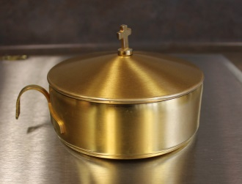
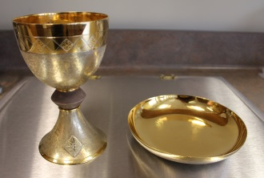
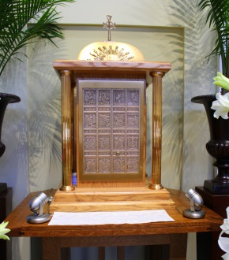
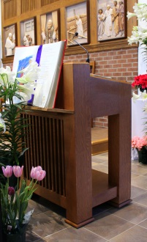
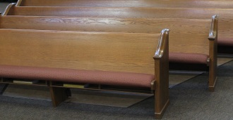
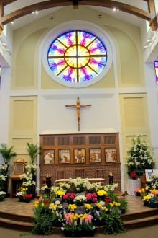

Pews

Lectern or Ambo

Sanctuary

Tabernacle

Ciborium

Chalice & Paten

