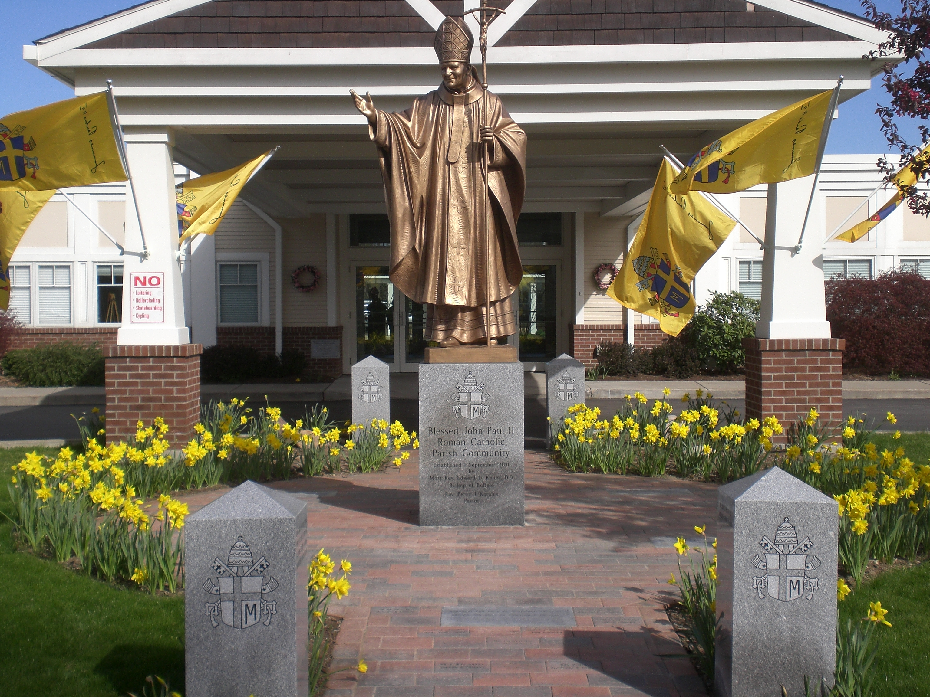

Saint John Paul II Parish Community
Heritage Walkway

Memorialize your loved one
or a Special Occasion!

Every generation does not have the opportunity to be part of the founding of a new Parish Community or to celebrate the canonization of their patron! The Saint John Paul II Memorial Walkway is a lasting way to remember and memorialize those that have come before us and those who have added unique and cherished components to our community of faith.

The Saint John Paul II Heritage Walkway is a beautiful part of our parish property. It is a wonderful opportunity to honor those whose faith has inspired and whose memory is not forgotten. It is also an opportunity to honor individuals and families who are living among us today and are founding members and/or families of Saint John Paul II Parish Community. The walkway is also an excellent way to commemorate special occasions such as baptisms, weddings, graduations, anniversaries, funerals, and other milestones in life. It is also a way to show support for the parish by having a family name engraved on one of the available items.

The Heritage Walkway truly enhances the entrance area of our church building with the statue of Saint John Paul II in the center. The walkway is comprised of 6” x 9” bricks along with eight 24” x 12” large granite pavers. Also, each of the two entrances to the walkway is marked by two granite posts. Each post has two sides that contain 10 two-line inscriptions for a total of 80 inscriptions.

Available walkway items are:

24”x12” granite paver $1500.00
(2 lines inscribed with 24 characters/spaces per line)

Two line inscription on granite entry post $750.00
(2 lines inscribed with 26 characters/spaces per line)

6”x9” inscribed brick only $150.00
(2 lines inscribed with 17 characters/spaces per line)

Please use the order form on the reverse to place your order.
Return your order form and payment to the parish office, by mail,
or drop it in the Sunday collection basket.

Saint John Paul II Parish Office Call the Parish Office with any questions:
2052 Lakeview Road PO Box 115 (716) 627-2910
Lake View, New York 14085

Saint John Paul II Parish Community
MEMORIAL WALKWAY

Order/Payment Form
Please remember to fill out both sides of this form.
Item

__ 24”x12” Granite Paver only $1500.00

__ 2-line Entry Post Inscription only $750.00

__ 6”x9” Inscribed Brick only $150.00

Please use one form for each item order. Payment can be combined on one form.

Total amount of purchase $_______________

__ Check # ________

__ Cash

Deposit amount $______________
Balance due (within 90 days) $_____________

Items will be inscribed upon receipt of full payment.

Signature: ____________________________________

PLEASE PRINT

Name: _______________________________________ Phone: ______________________________________
Address: _____________________________________ Town/State/Zip ________________________________
Email: _____________________________________________

