2023 First Eucharist
Artists Wanted

We need artwork for the programs that will be handed out to all that attend the First Eucharist Masses during the month of May. Any students making their First Eucharist are eligible to submit original artwork to be used anywhere in the program or signage.

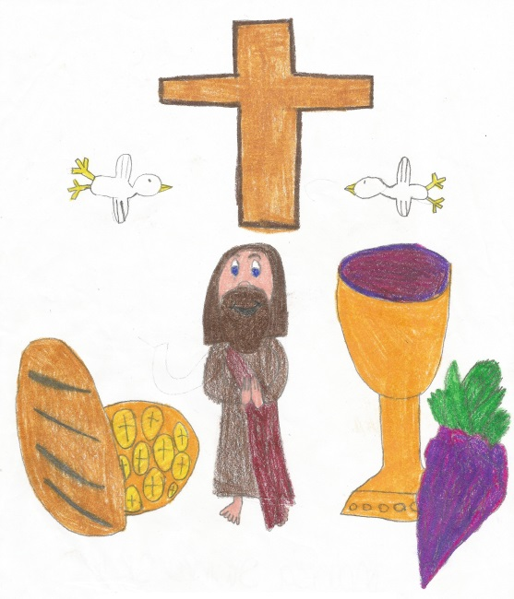
Our request is that the artwork is completed by the child only (No help, Mom & Dad!), the child must be part of this year’s 2023 First Eucharist class (no siblings) and it must be of the Eucharist/Religious theme (Host, Chalice, Cross, Dove, Cross, Etc.).

This is NOT a requirement. Students may submit more than one drawing, coloring or painting.
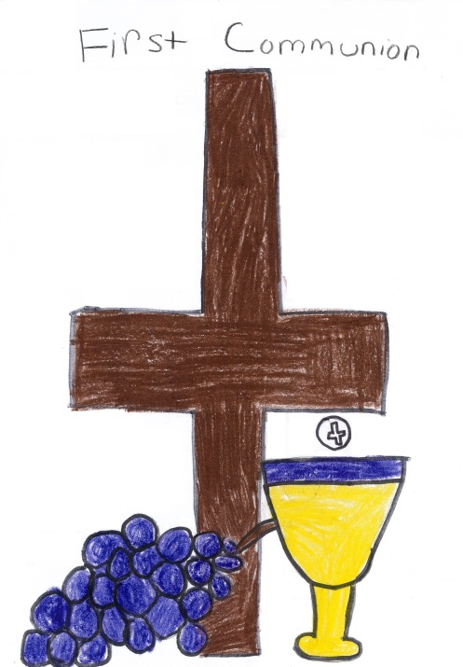
We may not be able to use all entries, but all entries will be considered and greatly appreciated.

We need all artwork by April 23th Please label all entries with first and last name on the back.

Have fun!

