**Christmas Project**

Have your child(ren) create a Nativity Scene from items found around the house. Here are some examples but feel free to USE anything that comes to mind. Please take a photo of it and email it to [Lori.s@jp2parish.org](mailto:Lori.s@jp2parish.org) for credit! It can be made as a family or each child can make their own. Get Creative!

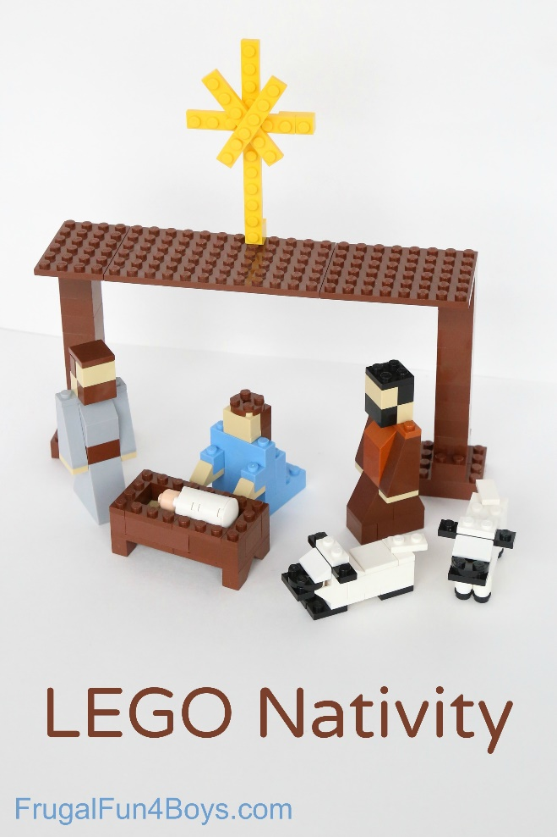

Legos

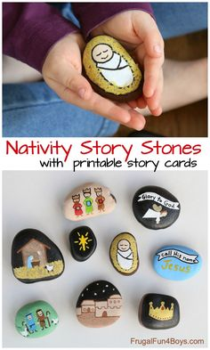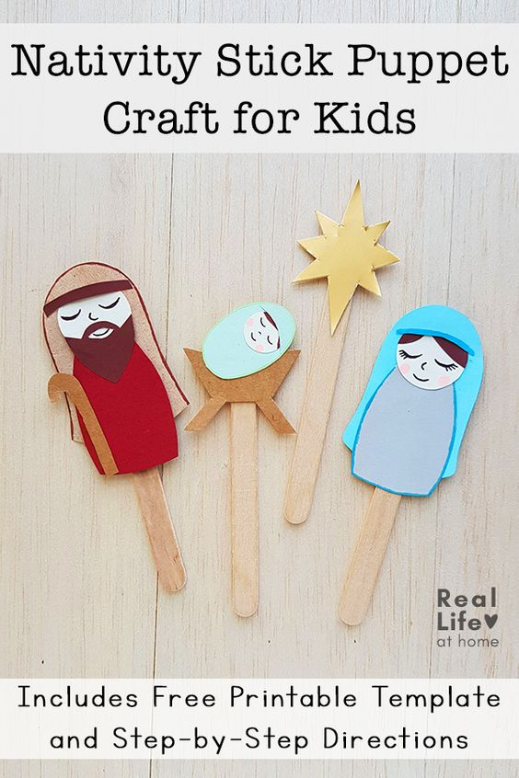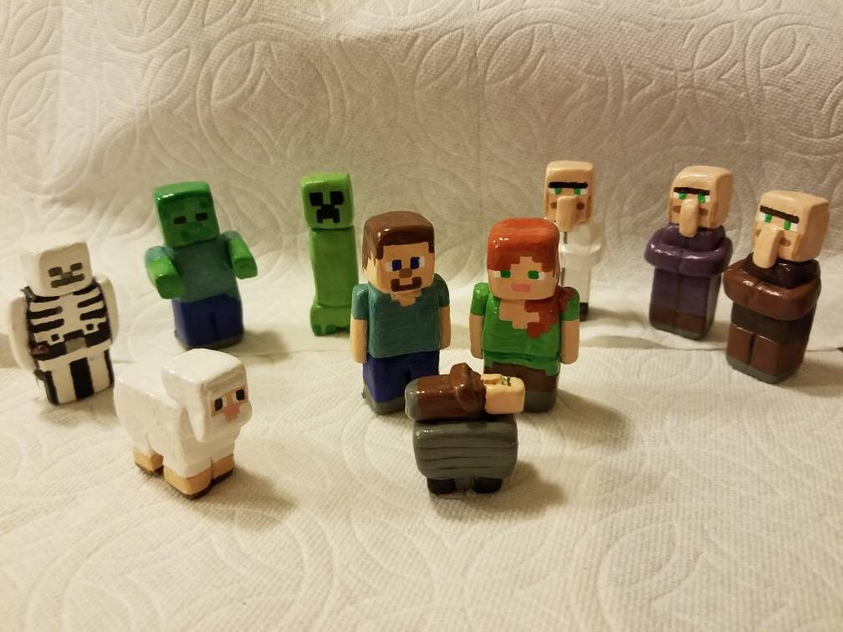

Rocks

Popsicle Sticks

Minecraft

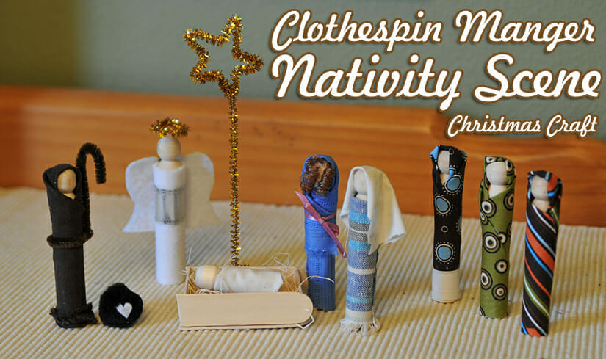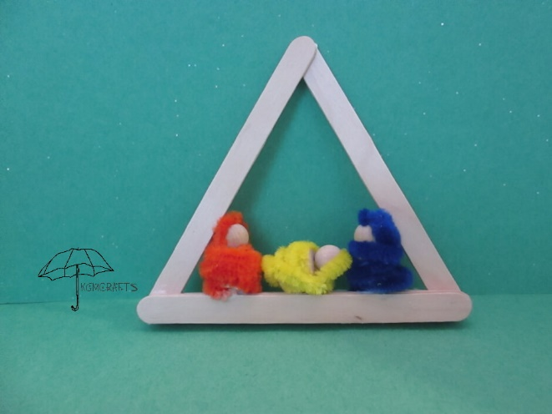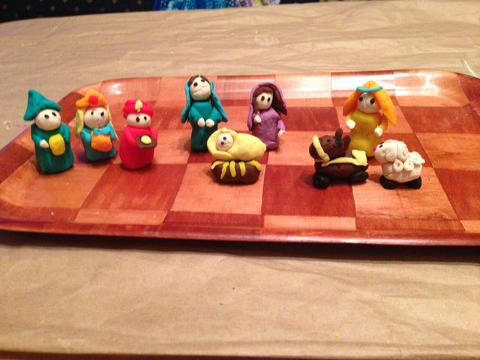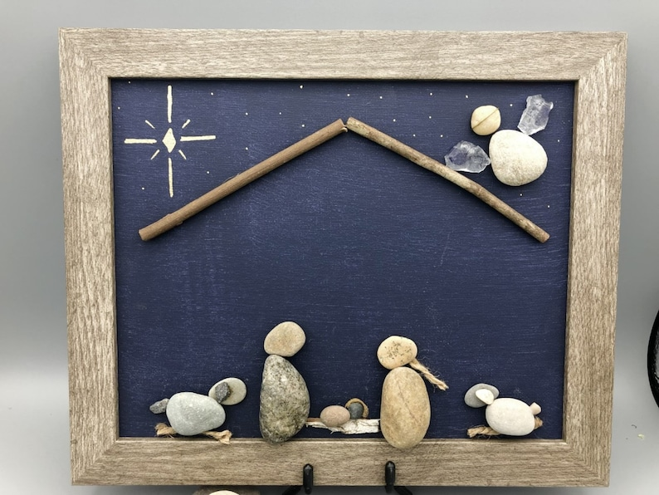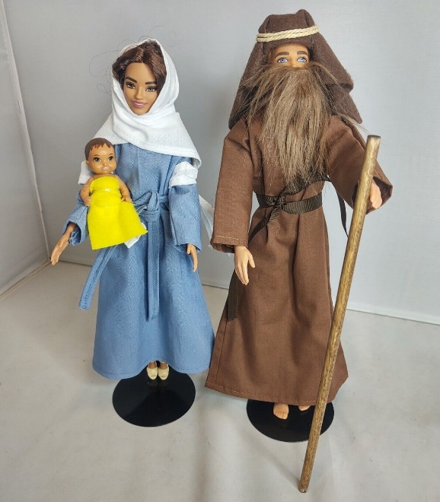

Pipe cleaners

Playdough

Stone/Pebble

Barbie