2nd Grade LITURGICALCalendar 2/25/24 Sub Lori Stoklosa
Use a liturgical calendar from your textbook Page 211

2. LITURGICAL YEAR LECTURE.
Introduce the students to the seasons of the liturgical year by writing a concise definition of each season on the board. Here are the definitions I used when I introduced the seasons to my elementary school students:
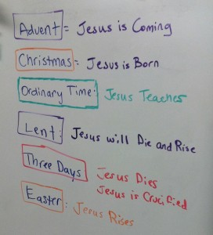
Show the cut out dolls, and the colors they wear for the different Seasons. Just the Purple, Green and White.
Took a trip to the Sacristy to see the Chasubles that Priests wear and re-enforce the colors of the seasons of the church. We ran into Father Mike Johnson and everyone got to meet him and say “hi”.
Answered questions about First Reconciliation.

Advent:
Getting ready for the birth of Baby Jesus a long time ago

Christmas: Baby Jesus is Born in Bethlehem and keeps going until the Wise Men meet Jesus

Ordinary Time: We learn about and follow Jesus’ Teachings

Lent: Prepares us for Easter and it’s time to do good deeds for others

Easter: We remember that Jesus rose from the dead a long time ago.
This celebration goes on for 40 days and then Jesus goes to Heaven.

Ordinary Time
again:
We learn about and follow Jesus’ Teachings

