Why do you think the Holy Spirit is depicted by flames or wind or a dove?

Can you think of other instances where people draw a symbol of something they can’t see?

An idea – A question or exclamation mark or thought bubble

Running fast - lines behind the runner

A load noise – a speaker with squiggly lines
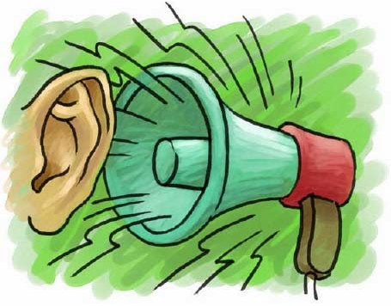
Excited – jumping for joy
Emoji’s show different emotions. Have you ever actually stuck out your tongue when you did something goofy or had hearts in your eyes when you saw something you loved? Why do we understand what they mean?

So, once again, why do you think artists used flames or wind or a dove to explain the Holy Spirit?

